A Guide To Lift Up Storage Sleigh Beds Varieties and Benefits

There is large variety of sleigh beds out there, and lift up sleigh beds are just one of them. Sleigh beds will probably never go out of style as they fit any interior and are easily customizable. You can change your bed so it perfectly suits your bedroom.

One disadvantage of sleigh beds is that they take up a lot of space, and there is usually no space left for cupboards or drawers to store your bed sheets and linens. One would say that it is not a good fit for smaller rooms.

Luckily, the manufacturers have found a solution for that. They included a storage space beneath and you just have to lift up the bed and you will have an entire space just for your bed sheets, blankets and pillows.

**Types of lift up sleigh beds include**: hydraulic lift up storage sleigh bed, ottoman lift up storage sleigh bed and the pull up storage sleigh bed.

## What Is a Sleigh Bed?

**A sleigh bed is** a type of bed where the headboard and footboard are curved and resemble a sleigh.

The sleigh bed was made popular during the 19th century in France and America, but its popularity continued to the present day.

It is usually made from heavy wood, which is a more traditional style. Today, sleigh beds are made from various materials such as wood, iron, steel, aluminium.

They come in different sizes, ranging from small one-person beds to extra queen sized ones.

They feature a beautifully curved headboard and footboard, which make them noticed as soon as you enter the room.

## Types of Lift Up Sleigh Beds

Here we are going to give you a brief description of every lift up storage sleigh beds.

### Hydraulic Lift Up Storage Sleigh Bed

A hydraulic lift up storage sleigh bed features a slat that is installed just above the bed frame. The slat is lifted altogether with the mattress up in the air and it uncovers a storage space that is of the same size as your bed. Here you can store whatever you want- from bed sheets and pillows to unused clothes.

The hydraulic system was designed to make things more accessible so you do not have to go through your big closet or stack your room with other storage furniture.

There should not be any difficulties in operating it. You just lift up the slat and put it back down. This is a perfect bed for people who want to hit two birds with one stone.

This type of storage sleigh bed comes in various styles- wooden, upholstered and modern.

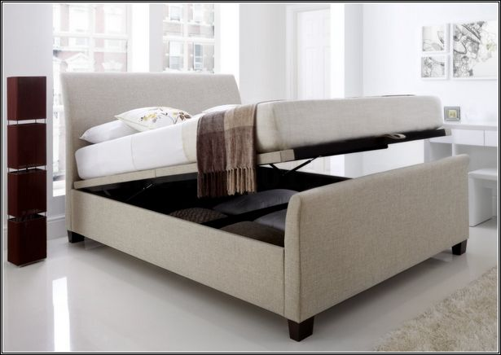

### Ottoman Lift Up Storage Sleigh Bed

Ottoman sleigh beds are very elegant and stylish, and like the hydraulic sleigh beds, the slat is mechanically connected to the bed frame, but this time on the side. However, you can find ottoman lift up sleigh beds where the slat is connected above the bed frame.

The location of the slat connection can be built on the right or left side to suit your needs or bedroom style.

It is easy to assemble an ottoman lift up storage sleigh bed. All manufacturers feature step-by-step instructions. If you purchase a single ottoman lift up sleigh bed it comes in one so you do not have to assemble anything. If you purchase a larger one, then it usually comes in 2-4 pieces.

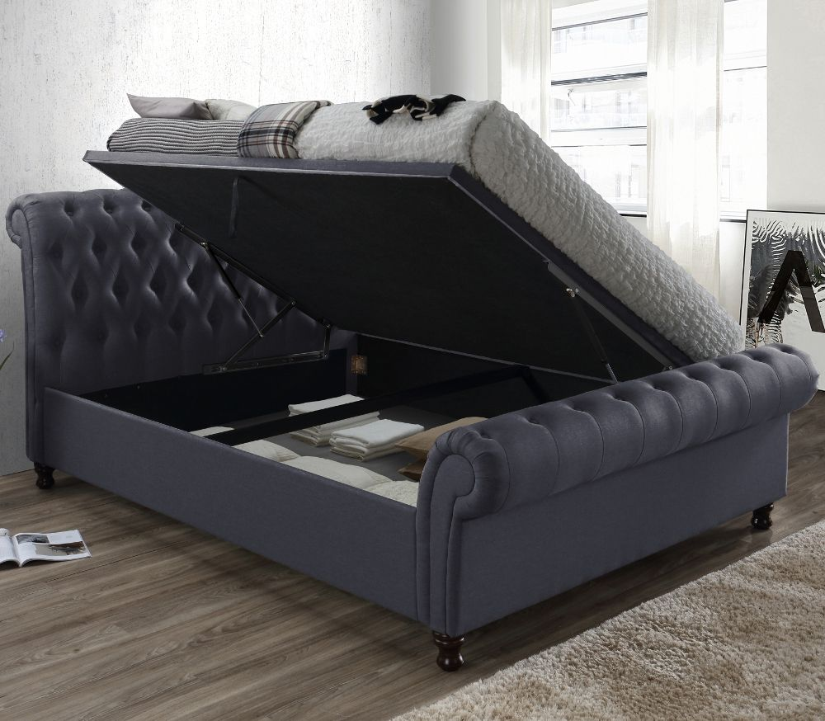

### Pull Up Storage Sleigh Bed

A pull up storage sleigh bed is very easy to operate. The bed slat is connected with a mechanism on either sides- on the sides or near the head and footboard. Some beds have half of the space, half of the side of the bed. The mechanism is situated in the middle of the bed and only Beneath it you have a huge storage space to store your belongings. It saves up a lot of space in your room, and also a lot of time, since everything you need for your bed or seasonal clothes is under your mattress.

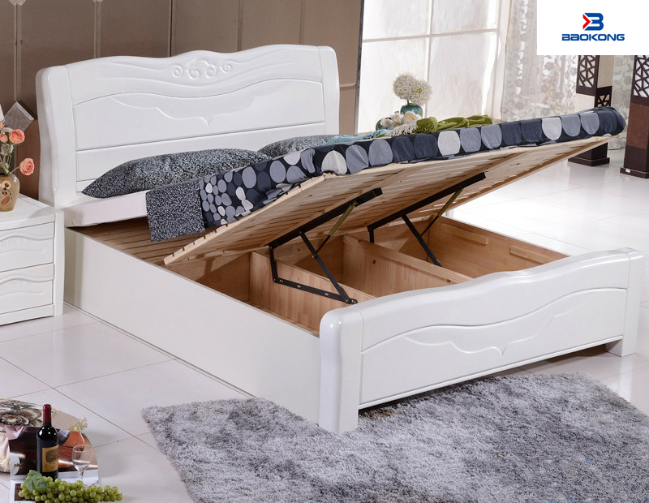

Here is a table that summarizes the types, qualities and price ranges of lift up storage sleigh beds:

|  |  |  |  |
| --- | --- | --- | --- |
| Type of Lift Up Storage Sleigh Bed | Key Features of This Type | Typical Price Range | Amazon Product Example |
| Hydraulic lift up storage sleigh bed | Accessible, spacious | $350-$1000 | [Tetra Hydraulic Queen Size Bed](https://www.karpentree.com/tetra-hydraulic-queen-size-bed-pst003.html) |
| Ottoman lift up storage sleigh bed | Accessible, practical, has a lot of storage space | $300-$1500 | [Luxury Crushed Velvet](https://www.amazon.co.uk/Crushed-Diamante-Diamond-Chesterfield-CosyWinks%C2%AE/dp/B07GZ6QR24) |
| Pull up storage sleigh bed | Easy to operate | $200-$800 | [Pull up Storage Sleigh Bed](https://www.alibaba.com/product-detail/lift-up-storage-bed_60677987327.html) |

## Traditional vs. Lift Up Storage Sleigh Beds

A traditional sleigh bed is in most cases made out of wood, in either light or dark colors. They have beautifully carved designs on the head and footboard which gives it a real vintage and authentic feel. They do not come with a storage space.

A lift up storage sleigh bed is on the other hand a bit more modern than the traditional one. It can also be made out of wood, but also it can be upholstered, modern, leather and so on. The mattress lays on a slat, and when you lift it up you uncover a storage space beneath it the size of the bed, where you can put anything you want.

There pros and cons for both types of beds. **The pros of traditional storage sleigh beds include** the authentic look and they are made out of full wood, **while the cons include** the size and style.

When something is made out of 100% wood you can rest assured that it will not go bad and not much can be damaged. You will probably have to sand it, paint and polish when you see cracks, and maybe change the bed reels, but nothing more than that.

Conversely, the traditional sleigh bed is quite big, and you will need a big room for it to fit. If your bedroom is not big enough, you will not have space for the rest of the furniture. Another con is that because of its vintage look, it will not suit all room styles. So if you are opting for a traditional sleigh bed, make sure that your entire bedroom is in wood and it resembles a 19th century master bedroom.

**On the other hand, the pros of lift up storage sleigh beds** include the storage space and style, **while the cons of lift up storage sleigh beds include** the mechanism damage and difficulty when moving.

The name says it itself- lift up storage space. With this type of sleigh bed you will get extra storage to put your clothes, linens, pillows, anything you want and thus save up space in your room and closet. It is easily accessible and practical. Moreover, this is a bit modern sleigh bed style and is more classic-looking. It will fit most room styles so you will not have to put much thought into whether or not will suit your bedroom.

However, it has some disadvantages. It is hard to maintain it due to its hardware and the lift up mechanism can be damaged. Over time, the screws and other parts can fall off or become loose and it will require repair. Furthermore, because of its size and many parts it can be difficult to move it around as It requires dismantling and putting it back together again.

## Lift Up Storage Sleigh Bed Heights

A typical bed height is around 24 inches from the floor, and that includes both the mattress and bed frame. The height of a lift up storage sleigh range from 25 to 36 inches, and are a bit higher than normal beds. And this is nothing unusual, since they have extra space below the mattress.

The bed height merely depends on you r preferences, but you should take into account your age and height. It is crucial that you pick the right height. If not, it can cause you back and leg pain, and overall it would not be as comfortable.

There are low, standard and high lift up storage sleigh beds.

The low lift up sleigh beds are around 25 inches tall and they provide less space than other storage sleigh beds.

A standard bed height is from 28 to 33 inches and this is the typical bed height for a storage sleigh bed, like the Ottoman lift up storage sleigh bed.

High beds are up to 36 inches, sometimes even higher. Antique and traditional beds are usually taller and they come with a large storage space.

Below are three examples:

|  |  |  |
| --- | --- | --- |
| Amazon Product Example | Height of Lift Up Storage Sleigh Bed | Storage Space Dimensions |
| [Castello Charcoal Fabric Ottoman Scroll Sleigh Bed](https://www.amazon.co.uk/Crushed-Ottoman-Castello-Charcoal-Chesterfield/dp/B06ZXZ34K9) | 91 cm | 190 cm x 135 cm x 25..5 cm |
| [Allendale Black Faux Leather Ottoman Storage Bed](https://www.amazon.co.uk/Kaydian-Allendale-Leather-Ottoman-Storage/dp/B00CXT7FMM) | 89 cm | 197 cm x 133 cm x 27 cm |
| [Home Treats Winfield Ottoman Bed Frame](https://www.amazon.co.uk/dp/B07ZTQDT3T?tag=dealsan03-21&linkCode=osi&th=1&psc=1) | 100 cm | 210 cm x 145 cm x 29 cm |

## Different Sleigh Bed Dimensions for Lift Up Sleigh Beds

Lift up sleigh beds come in different sizes. A king lift up storage sleigh bed measures 80 by 76 inches, a queen sleigh bed measures 80 by 60 inches, a twin size storage sleigh bed measure 38 by 75 inches, the double sleigh bed measures 74 by 54 inches and the full lift up storage sleigh bed measures 75 by 53 inches.

### King Size Storage Beds

The length of a king size lift up storage sleigh bed is typically 80 inches and the width is around 76 inches. It is a Perfect bed for families who like to cuddle together with their children and pets. The king size lift storage sleigh bed has plenty of space under it. Here you can store pillows, bed sheets, pyjamas, shoes, seasonal clothes and other stuff you do not use every day.

### Queen Size Storage Beds

The queen is 80 inches long and 60 inches wide. It is a perfect bed for couples as it gives plenty of space for both. It is a great wit for master bedrooms. Plenty of space under the mattress where you can store clothes, bed sheets and so on. It is a bit smaller than the king size lift up storage sleigh bed, but there is still a lot of space.

### Twin Size Storage Beds

A twin size storage sleigh bed is the smallest bed out there. It is around 38 inches wide and 75 inches long. Children usually sleep on this bed. There is also a Twin XL sleigh bed which is 38 inches wide and 80 inches long. Here you can store seasonal children’s clothes, backpacks and some toys. However, there still isn’t that much space for all of it.

### Double Size Storage Beds

Double size lift up storage sleigh beds are generally 74 inches long and 54 inches wide. They offer extra space. Sometimes the space beneath is divided with wooden boards and thus separates the things you want to store there so you have a place for your bed sheets and blankets, shoes, clothes and so on.

### Full Size Storage Beds

A full size lift up storage sleigh bed is 53 inches wide and 75 inches long. It is just a couple of inches wider than the twin size bed. This makes it perfect for one person as it provides a lot of space. Under it you can store whatever you are not using at the moment like seasonal clothes, shoes, bed sheets, blankets and towels.

|  |  |  |  |
| --- | --- | --- | --- |
| Sleigh Bed Size | Amazon Product Example | Dimensions | Storage Area Dimensions |
| King | [Marseille White Wooden Ottoman Storage King Size Bed Frame Only](https://www.time4sleep.co.uk/products/marseille-white-wooden-ottoman-storage-king-size-bed-frame-only) | 62 x 88 inches | 60 x 86 x 22 inches |
| Queen | [MALM](https://www.ikea.com/ca/en/p/malm-pull-up-storage-bed-black-brown-90404817/) | 83 x 66 inches | 80 x 60 x 11 inches |
| Full | [DHP Cambridge Bed with Storage, Full Size Frame](https://www.amazon.com/DHP-Cambridge-Upholstered-Platform-Headboard/dp/B07Z9ZP32J/ref=sr_1_4?dchild=1&keywords=Full%2BSize%2Bottoman%2Bstorage%2Bbed&qid=1620126786&sr=8-4&th=1) | 79 x 56 inches | 77 x 54 x 13 inches |
| Double | [Seville Ottoman Bed](https://www.time4sleep.co.uk/products/seville-ottoman-bed-mid-grey) | 87 x 57 inches | 85 x 55 x 13 inches |
| Twin | [Twin Side-Lifting Storage Bed](https://expandfurniture.com/product/reveal-twin-side-lifting-storage-bed/) | 81 x 44.5 inches | 79 x 42 x 13 inches |